Title
How to Plan Your Week So Your Goals Don’t Get Ignored
Keywords
weekly planning, goal setting, productivity, time management, consistency, personal growth, focus, weekly priorities, actionable tasks, review and reflection
Short Description
Stop letting your goals get buried under a busy week. This article presents a simple, practical method for planning your week intentionally, staying focused on what matters most, and making consistent progress toward your bigger goals.

How to Plan Your Week So Your Goals Don’t Get Ignored
Every week starts the same way.
You tell yourself, “This week will be different.” You plan to work on your goals, stay focused, and finally make progress.
Then life happens.
By Friday, you have been busy nonstop, yet the one thing you promised yourself to do barely got any attention. The weekends, and your goals are pushed to “next week” again.
The problem is not that you don’t care about your goals or that you lack discipline. The real issue is that most goals fail at the weekly level. Without a clear plan for the week, your goals get crowded out by urgent tasks, distractions, and daily responsibilities.
In a previous article, we talked about setting clear goals and working in focused 12-week cycles. But goals alone are not enough. They need a weekly plan to survive.
In this article, you’ll learn a simple, practical way to plan your week so your goals are not forgotten, ignored, or postponed, but intentionally built into your everyday life.
Why Most Weekly Plans Fail
Many people sit down on Sunday, write a long to-do list, and feel productive. But by midweek, that list is ignored.
The problem is not planning itself; it is how we plan.
- Most weekly plans focus on everything except what truly matters. They are filled with errands, meetings, chores, and requests from other people. Your goals end up buried at the bottom of the list, treated as optional instead of essential.
- Another issue is overplanning. When you try to do too much in one week, you set yourself up for frustration. The week becomes more about survival than progress. Eventually, you stop trusting your plans because they never seem realistic.
- There is also no connection between the weekly plan and your bigger goals. When your week is not clearly tied to what you are trying to achieve in the next 12 weeks, it becomes easy to say, “I’ll do it later.”
A good weekly plan does not try to control every minute of your day. Instead, it protects space for what matters most. Once you understand this shift, planning your week becomes simpler and far more effective.
Start With a Weekly Reset
Before you go into planning, take a moment to clear your head. A weekly reset is like hitting the refresh button for your mind. It helps you start with clarity.
Begin with a brief review of last week:
- What tasks actually moved you closer to your goals?
- Which actions didn’t get done and why?
- What lessons can you carry into this week?
Next, focus on the week ahead by asking yourself three grounding questions:
- What matters most this week? Identify the few things that will have the biggest impact on your 12-week goals.
- Which goal needs attention now? Prioritize the goal that requires focus this week.
- What would make this week feel successful? Visualize the week ending with progress and achievement. This gives direction to your planning.
This weekly reset is simple but powerful. It clears mental clutter, brings your goals into focus, and ensures that the actions you schedule are intentional, not just reactive. Starting your week this way makes it far easier to follow through and actually achieve what matters most.
Choose Your Weekly Priorities
After your weekly reset, it’s time to decide on your weekly priorities. These are the few things that will truly move you closer to your 12-week goals.
Too many priorities will spread your energy thin and make it harder to make progress.
The rule is simple: less is more. Focus on what matters most.
Here’s how to choose your priorities:
1) Limit yourself to 3–5 priorities for the week. Pick the ones that will have the biggest impact on your goals.
2) Tie them directly to your bigger goals. Ask yourself: “Which actions this week will move me closer to achieving my 12-week goals?”
3) Focus on outcomes, not just tasks.
- Outcome: “Complete two client meetings this week”
- Task: “Check emails and make calls”
Examples of weekly priorities for different goals:
- Business growth: prepare product samples, reach out to five clients, schedule content for the week
- Exam success: complete two study sessions, review practice questions, and analyze mistakes
- Personal development: read one chapter each morning, write reflections, practice a new skill
Clearly defining your weekly priorities removes decision fatigue and gives your week focus. Each day, you know exactly what deserves your attention.
Create a Simple Weekly Plan and Review It
The goal of a weekly plan is to clearly identify your priorities, schedule them, and track your progress.
Here are some templates you can make use of :
Simple Weekly Planning Template


Daily Focus & Actions
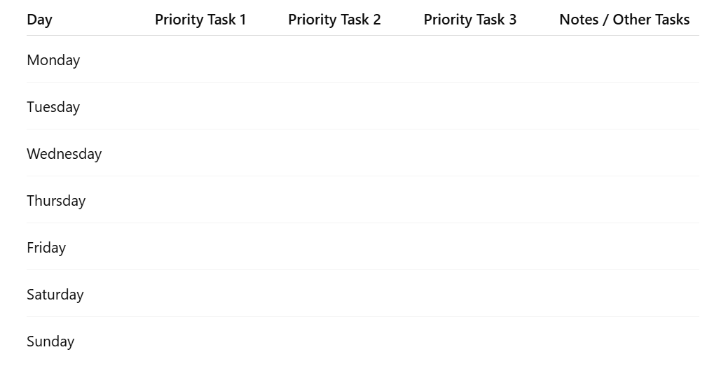

Weekly Review Questions
At the end of each week, take 10–15 minutes to reflect:
- What tasks moved me closer to my goals?
- Which tasks didn’t get done and why?
- What can I adjust next week to stay on track?
This short review helps you learn from each week, improve your planning, and stay consistent with your 12-week goals.

Closing
Planning your week intentionally is a skill that grows stronger the more you practice it. The act of choosing what truly matters and giving it space in your week transforms your goals from ideas into results.
Now it’s over to you: how do you plan to structure your week differently starting today? What has worked for you in the past, or what challenges do you face when trying to stick to a plan?
Share your thoughts, experiences, or questions in the comments or with a friend. Your approach might inspire someone else to take control of their week, too.

